Version 1.0

October 10, 2019

Refreshing Database

cARMELA PHAM

SURF CITY SOFTWARE CONSULTING, INC

9151 aTLANTA #8236 huntington beach, ca 92615

# About This Document

This document will list the steps to import database from Excel Schedule Tool to the current .NET app.

# procedure

## create backup

Before anything else, create a backup of your existing database.

## RESTORE BACKUP

This step can be skipped if you want to work on the existing database. Otherwise, you can restore the backup created in the previous step and work on the new database instead. This is ideal as other programmers may still be working on the data in the old database. They can move to the new database when they are ready by updating the database location on APPSETTINGS.JSON

## Setting Up the Source Database

I typically ask the DBA to give me a copy of the PROD copy of the Excel Database into OCEANVM112 (the current database server). He usually names it SCHEDULE_PDB_502. This is the source database. If the source database is not SCHEDULE_PDB_502, replace all instances of the string *SCHEDULE_PDB_502* with the name of the source database.

## run the script

1. From source control, get the latest copy of ***3 – DBSeed.sql*** ON ***$/ScheduleTool***, the master copy of ScheduleTool.
2. Update the first line to point to the database you want to import data into  
   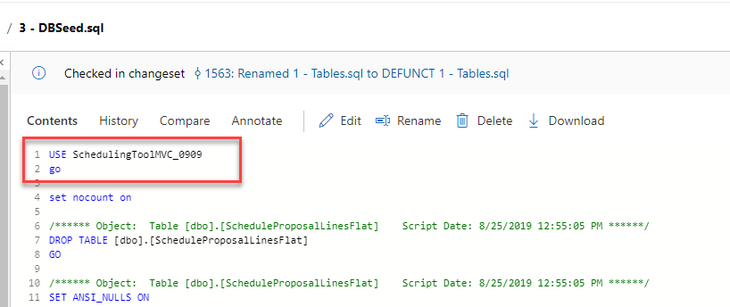
3. Run the script.

# Other Notes

## The Tables

The script we will run will wipe out data from the following tables:

* ScheduleProposalLinesFlat
* PRELOG_LINE_T
* POSTLOG_TEMP_T
* POSTLOG_LINE_T
* POSTLOG_T
* SCHED_WEEK_LOCK_T
* UpfrontNotes
* UpfrontExpansionTrackingLines
* UpfrontExpansionTracking
* UpfrontExpansionNetworkGroup
* UpfrontLines
* ScheduleLines
* Schedule
* Upfronts
* Rates
* PropertyHistory
* CanadaActualExchangeRates
* BroadcastDate
* DealPoints
* CommRate
* CanadaClientExchangeRaets
* EdiClientLookup
* ClientUserJob
* NetworkUserJob
* Dayscodes
* BuyType
* DoNotBuyType
* Properties
* Splits
* EdiNetworkLookup
* Networks
* UpfrontTypes
* Clients
* DemographicSettingsPerQtr
* DemographicSettings
* Quarter
* ScheduleTypes
* Jobs
* DayPart
* Logs

## Stored Procedures and Functions

Stored procedures and functions will not be updated during refresh.

## Permissions

At the time of this writing, the permission scripts are stored in 2 – DBSeed.sql. However, these needs to be updated as we finalize permissions in the application.

## Client ID

The client called ***NOT A CLIENT*** was often hard-coded in the Excel Schedule Tool. That was carried over to the .NET version. It is important that this client be assigned the ID “17”. I might go back and do a string comparison instead so I might have to remove this note later.

## Mher’s Changes

The following are tables that Mher imported into the new database. At the time of this writing, I do not understand what these tables do. There were no scripts provided but it looks like it actually didn’t need to be updated. So no additional changes in the script were done for this.

